Automatic Identification and Classification of the Red-Sea Trough and its Application for Climatological Analysis

Hadas Saaroni, Tzvi Harpaz, Pinhas Alpert, Baruch Ziv

**Abstract**

The Red Sea Trough (RST) is a low-pressure system extending from south toward the Eastern Mediterranean and the Levant. This system is the most frequent among all easterly troughs that extend from North Africa toward the Mediterranean, and is attributed to the lee effect of mountain ridges east of the Red Sea.

Unlike previous synoptic classifications for the Levant, which cover all systems affecting the region, our algorithm aims at the RST alone. Each RST is classified as one of three types, according to the location of the trough axis with respect to 35°E longitude. For that end, we use the sea level pressure relative geostrophic vorticity. These two fields are interpolated to a 0.5°x0.5° resolution. The following conditions has to be met in order for a case to be identified as RST day: (i) north to south SLP drop across the Levant area, (ii) average positive relative vorticity over that domain, (iii) the existence of a distinct trough axis from the low pressure toward the domain along a continuous line and (iv) the absence of any pronounced closed cyclone in the region of interest. The algorithm was applied on the ERA Interim, in 2.5°×2.5° and 0.75°×0.75° resolution and the NCEP reanalysis, with 2.5°×2.5° resolution.

An evaluation of the automatic classification, done for randomly selected 627 days showed a degree of agreement between the algorithm and subjective identification done by trained forecasters that varied between 87% and 96%. For the 279 days, which were identified as RST days by both the algorithm and the forecasters, in 79% of them the classified was similar. The algorithm was applied on the 3 data sets in order to compare the effect of the analysis methods and the spatial resolution on the RST distribution. The highest match was found between the two data sets of the ERA Interim, 85%, presumably due to the similar processing method applied in them. The lowest match was found between the NCEP (2.5°×2.5° resolution) and the fine resolution (0.75°×0.75°) data set of ERA Interim, 78%, due to the cumulative effect of the different resolutions and different methods of analysis.

The long-term mean yearly distributions derived from the 3 data bases show the following common characteristics: the autumn is the main season of RST, with a maximum is in November and a gradual and consistent decrease from December toward the yearly minimum in July. The annual average frequency is

It was found that the trough axis has a diurnal oscillation; it tends to be located near the eastern coast of the Mediterranean at nighttime (00UTC) and shifts eastward (inland) toward noontime (12UTC).

Long-term trend

The fully automated algorithm is not tailored to any predetermined spatial resolution, so it is applicable to a variety of reanalysis datasets, operational forecast model results and climate model outputs.

1. **Introduction**

The Red Sea Trough (RST) is a low-pressure system extending toward the Levant from the south. It is one of the northward extensions of the African Monsoon, and the most frequent of these, attributed to the Lee Effect of continuous mountain ridges along the Red Sea (e.g., Ashbel 1938, Kahana et al. 2002, Alpert et al. 2004a, Tsvieli and Zangvil 2005, demonstrated in Figs. 1a-c). It is present during 19% of the days annually: mostly in the fall, slightly less during the winter, and fades out by mid-spring (Ref for the 19%). The RST transports hot and dry air from the Arabian Peninsula and surroundings toward the Levant via southeasterly winds, often accompanied by haze or dust storms. It is mostly a lower-level system, accompanied by upper-level westerlies or by anticyclonic flow, hence mostly without rain over the East Mediterranean (EM, e.g., Saaroni et al. 1998, Lionello 2012). During conditions of dry air, implied by the lower-level easterly flow (e.g., Saaroni et al. 1998), when upper-level dynamic ascent does not exist, the resulting RST is a dry system with no rain (Dayan et al. 2001, Ziv et al. 2005). Southeasterly winds which blow the dry air over the sandy basins in Saudi Arabia, Iraq and Syria often give birth to dust storms and transport this dust westward toward the Levant (Dayan et al. 2008, Enzel et al. 2008, Ganor et al. 2010a, b, Erel et al. 2013). Alpert et al. (2004b) found that a sharp increase in their frequency during the period 1948-2000.

The first attempts to identify the RST were made by Koplowitz (1973), Ben-Rubi (1980) and Ronberg (1984), as part of an automated classification of the regional synoptic systems. They based their method on observations of Middle Eastern meteorological stations. Shafir et al. (1994) were the first to use gridded data for classification of synoptic systems in the EM.

The widely used synoptic classification is the semi-objective method of Alpert et al. (2004a). The system is applied to gridded data of the Levant, which includes 1000-hPa geopotential height (gph), temperature, and wind components for 12UTC, obtained from NCEP/NCAR reanalysis, at a 2.5°×2.5° resolution (Kalnay et al. 1996, Kistler et al. 2001). This classification methodology started with 5 predefined synoptic systems, which are frequent in the Middle-East, e.g., Cyprus Low, Persian Trough and the RST. Each system was further subdivided into 19 synoptic types according to the feature which is most relevant for the weather in Israel, such as its location and/or intensity. After establishing the 19 types, 5 weather forecasters subjectively classified a learning set of one-year + one additional winter of daily synoptic maps. Each day from the learning set was saved as a vector containing its gridded data. When the classification system receives a vector of gridded data for an unclassified day, the distance of this vector from the vectors of each day in the learning set is calculated. The input day is assigned the class of the closest vector found.

According to the classification of Alpert et al. (2004a) the RST system is divided into 3 types, depending on the relative geographical position of the trough line, denoted also as the 'axis', with respect to Israel (exemplified in Figs. 1a-c). Each type implies different weather conditions, which depend on the wind direction that depends on the direction of the pressure gradient, which is determined by the position of the axis (e.g., Saaroni et al. 1998, Goldreich 2003, Tsvieli and Zangvil 2005).

Tsvieli and Zangvil (2005) developed an automated algorithm for identifying an RST and the location of its axis with respect to Israel. However, this algorithm, based on SLP alone, has been tailored to specific non-standard dataset of NASA, for the period of 1985-1995.

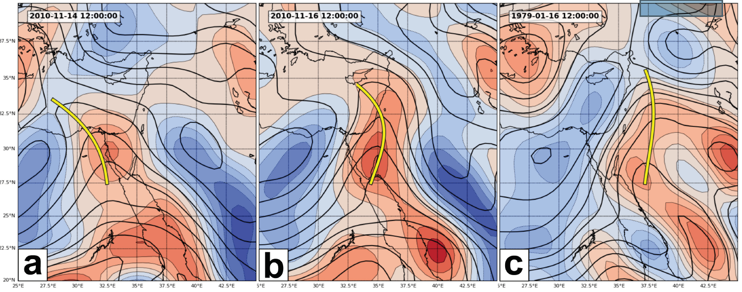

Fig. 1: SLP (Pa) and geostrophic vorticity (s-1), exemplifying the 3 types of RST according to its axis location: (a), (b) and (c) show examples of RST axes to the west, center and east of Israel, respectively. The axis in each figure is represented by a thick yellow line

Dayan et al. (2012) performed a manual (subjective) synoptic classification, based on sea-level pressure (SLP) maps, for a ten-year time period (1995-2004), and compared their results to the semi-objective classification of Alpert et al. (2004a). More than 50% disagreement was found between the two classifications, for each of the three subtypes of the RST. This is far beyond the 10% rate mismatch obtained by Frakes and Yarnal (1997) for well-defined pressure systems with steep gradients.

**צביקה רוצה להשוות את שלנו עם של דיין. הדס, בחרי מהאקסל של קורי 100 ימי ים סוף ו 100 ימי לא אפיק ים סוף (לא כולל יוני-ספטמבר) וצביקה ישווה עם הגדרת האלגוריתם, מבלי להיכנס למיקום הציר.**

The weakness of the automated classification of Alpert et al. (2004a) might be attributed to several factors. One is the coarse spatial resolution of the data, 2.5°X2.5°, which may imposes difficulty in determining the exact location of the RST axis, but not necessarily the existence of the RST itself. Second is the approach of Alpert's method, which attempts to cover all regional synoptic system, rather than one, like is done for the RST in this study. The proximity of the RST to another synoptic system in the region (e.g., High to the north, west or east of Israel, or a weak Cyprus Low, see Saaroni et al. 1998) makes the distinction between the RST and any of these systems difficult. The third is the arbitrariness of the area on which the semi-objective classification is based on, extending over 27.5°-37.5°N, 25°-35°E domain. Moreover, each grid point attains a similar weight in the calculations. The area occupied by an RST may cover only 1/4 of it, while another system, such as a cyclone over Turkey, may co-exist. In such a case the choice of the automatic software is not necessarily RST, though this system is closer to Israel and is probably more relevant for the weather there.

There is need for an improved automatic method for classification of RST, which overcomes the weaknesses specified above as much as possible. The present study aims to offer a flexible algorithm, which target is to identify the RST alone and to classify it according to the position of its axis with respect to the Levant. The algorithm does not depend on the spatial resolution of data source. Section 2 specifies the algorithm developed and stress the rationale behind its design. Section 3 evaluate the algorithm performance and elaborates its response to variations in the data source and resolution and some presents climatological features of the RST, as derived by applying the algorithm on data bases. Section 4 discusses and summarizes the characteristics of the algorithm and the results.

1. **Data and methods**

The purpose of the algorithm is to identify and classify RSTs at a given point in time, based on atmospheric data supplied by any data source, i.e., reanalysis or model output with wide range of spatial resolution. To achieve this goal, and to circumvent the weaknesses of the current automatic classification used in this region (specified in Sec. 1 above), the domain covers the northern Red-Sea and Israel and the fields used are the sea level pressure (SLP) and geostrophic vorticity. The following steps are executed in order: pre-processing the input data, locating the troughs axis, examining necessary conditions for RST existence and, if identified, classification.

* 1. *Input and pre-processing*

To permit input data from different sources with various resolutions, data is first interpolated to a common grid of 0.5°X0.5° resolution. Such an interpolation of the SLP data was found optimal for identifying and locating the trough axis, see Sec. 2.2 below. The same interpolation procedure is applied on the geostrophic vorticity field, which is calculated first from the raw data.

* 1. *Locating the trough axis*

The algorithm seeks for initial local SLP minima, which can be regarded as potential cores of an RST, extending northward. The searched domain is: 27.5°N - 30.5°N, 30°E – 42.5°E. A grid point is considered as having a local minimum if it has a lower SLP value than both its neighboring grid points along at least one line along 4 directions: north-south, east-west, southwest-northeast and northwest-southeast, at a range of ~1.5°.

If a local minimum is found, the algorithm looks for a local minimum in its immediate neighborhood (which is not to the south of it and must have a higher SLP value) that is a candidate for being the next point in the trough axis. As long as such minima are found, the algorithm keeps looking further for possible next points in the trough. When none is found, the search stops and the grid points that were recorded along the way are considered a trough axis.

It was found for many troughs that different, yet close, trough axes merged, eventually, into one, as is exemplified in Fig. 2a, b. These are considered as one axis, and its path is considered as follows: for each latitude, in which at least one merging axis exists, the average between the highest and lowest longitudes of all merging axes is considered as the merged axis longitude for the pertinent latitude. This way the algorithm clears each map from multiple merging axes and leaves at most only 3 axes most of the time (and very often, only 1). These merged axes are the candidates when selecting the RST major axis for a given day.

Due to the discrete process of its derivation (Figs. 2c), the trough axis looks as a kinked chain of straight segments. Hence, it is displayed after being smoothed.

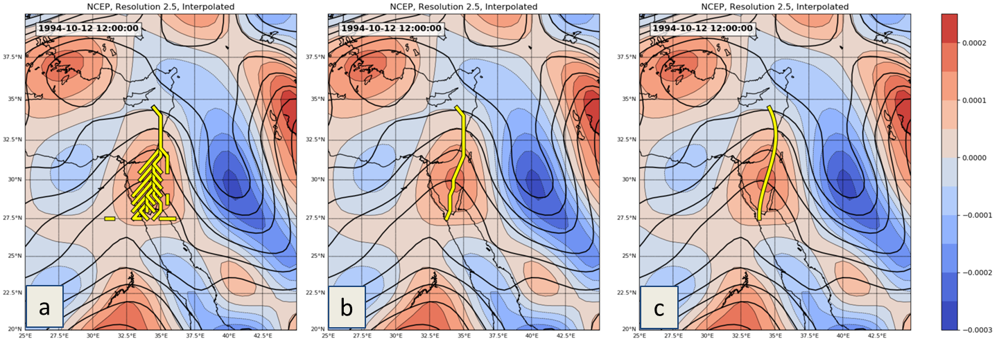Fig. 2: SLP (contours, in hPa) and geostrophic vorticity fields (colors, in s-1) for 12 October 1994 12UTC including all axes (a), with the merged axis (b) and with the smoothed merged axis (c)

* 1. *Conditions for RST existence over the Levant*

Considering that the RST is a cyclonic system that dominate the Levant region, which core is south of it, four conditions were specified to be met.

The first is the 'SLP gradient' condition, i.e., that the SLP decreases from north to south across the Levant region. The algorithm calculates the average SLP within two areas: 31°N - 35°N, 32°E – 38°E and 27°N - 31°N, 32°E – 38°E (see Fig. 3). If the first value is higher than the second, the SLP gradient condition is met.

The second is the 'vorticity condition'. If the average geostrophic vorticity over the region of interest, 29°N – 33.5°N, 32°E – 38°E (see Fig. 3) is positive, the vorticity condition is met.

The third condition is that no distinct closed cyclone (such as Sharav Low, see example in Fig. 4) dominates the region. This does not refer to shallow lows that may develop inside an RST. To identify such dominating cyclones, we look for well-defined Sharav Lows at the 25°-32.5°N, 25°-35°E region and for Eastern Lows at the 35°-42.5°N, 30°-35°E region. A low center (SLP minimum) found in these regions is considered as dominating the region if it has a mean depth of at least 160hPa (low strength) at a radius of 300Km and at least 75hPa to each direction (low shape).

The last condition is obviously finding at least one candidate RST trough axis.

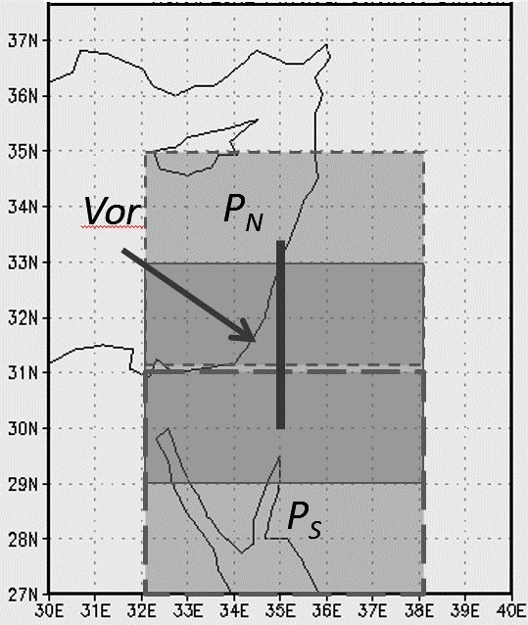

Fig. 3: The reference regions used for analyzing the RST. The areas denoted *PN* and *PS* are the northern and southern regions, respectively, over which the average SLP is calculated to verify pressure drop from north to south. The area denoted *Vor* is the one over which the vorticity is averaged (dark grey). The thick line along the 35°E longitude is used for determining where the RST axis is located relative to Israel.

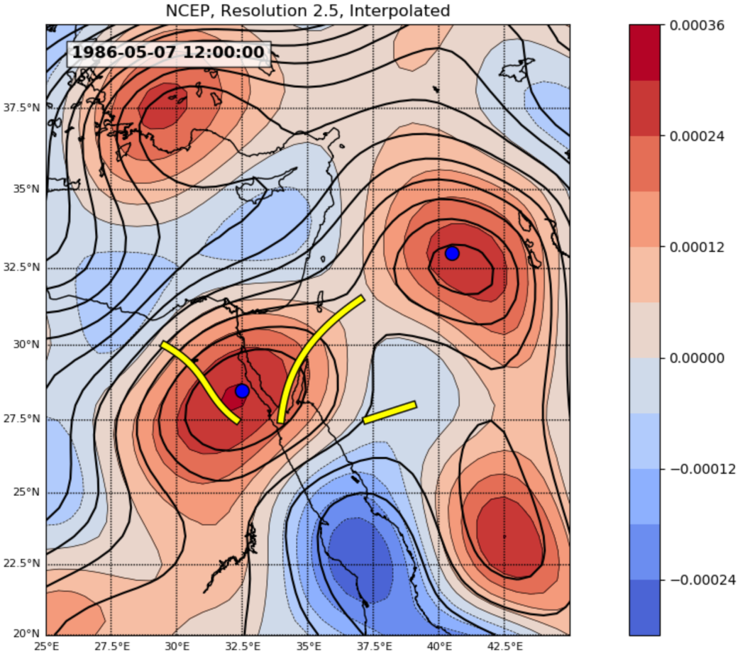

Fig. 4: SLP (contours, in hPa) and geostrophic vorticity fields (colors, in s-1) for 7 May 1986 12UTC, showing a case in which the 3 first conditions for RST identification were met but the 4th concerning the existence of a nearby major cyclone indicated that it was an incidental passage of a Sharav Low. The case was classified as 'No RST'

* 1. *RST classification*

If not all RST conditions are met, the final classification for the input map is 'No RST'. Otherwise, all merged troughs found earlier are examined in order to select the dominant one, according which the RST would be classified. Each merged trough is classified as one of the following classes: No RST, RST with an Eastern axis, RST with a central axis or RST with a Western axis. according to its relative location to the region 30°N – 33.5°N, 32.5°E – 37.5°E (see rectangle denoted "Vor" in Fig. 3). If the trough axis does not cross this region, the trough is classified as 'No RST'. If a trough axis is found only in the Eastern (Western) half of the region, it is classified as a trough with an Eastern (Western) axis. A trough that crosses the region through the line separating between its western and eastern halves is classified as an RST with a central axis.

If more than one of the merged axes exist in a given map (see example in Fig. 5), all merged axes receive a Geostrpohic Voritcity score (GV score) and the one with the highest is selected as the RST axis for that map. A GV score is the sum of GV values in the grid points along the axis. This selection method was found to effectively balance axis length and depth, as both are important factors for selecting the right RST axis. The classification of the selected RST axis is the final classification for the input map.

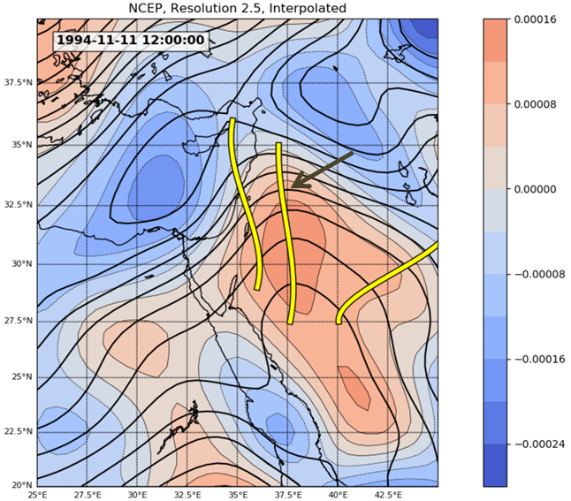

Fig. 5: SLP (contours, in hPa) and geostrophic vorticity fields (colors, in s-1) for 11 November 1994 12UTC including the 3 merged axes. The axis with the highest GV score, denoted by an arrow, was selected and identified the RST as 'RST east'

* 1. *Data used*

To test and tweak the algorithm, data was taken from the ERA-Interim reanalysis (Uppala et al., 2005; European Centre for Medium-Range Weather Forecasts, 2009; Dee et al., 2011) with 0.75°X0.75° and 2.5°X2.5° spatial resolutions, and from the NCEP/NCAR reanalysis archive at a 2.5°X2.5° spatial resolution (Kalnay et al., 1996; Kistler et al., 2001). The study period corresponds to the availability of the ERA-Interim data, i.e., 1979-2016. The data was taken for this region: 20°N – 50°N, 20°E – 50°E.

**יתכן שכדאי לחרוג מהתקופה כדי להתעמת עם מגמות השנוי שהתגלו על ידי פנחס**

1. **Results**
   1. *Evaluation of the algorithm*

The skill of the new algorithm was evaluated by comparing its identification of RST and its classification into the three types with these of our (3 trained forecasters) subjective identification and classification. Following Alpert et al. (2004a), the analysis was based on the NCEP-NCAR reanalysis data base, used by them. Table 1 presents the degree of agreement that was found between the algorithm and the subjective identification for 627 randomly selected days out of the database, covering all the months of the year, except July-August, in which the RST does not prevail (see Sec. 1 and the climatological results in Sec, 3.3 below).

The degree of agreement between the automated identification and the subjective one varied between 87% and 96%. For the 279 days, which were identified as RST days by both the algorithm and the forecasters, 87% were classified also as the same type. An agreement in identification in the order of 10% is defined by Frakes and Yarnal (1997) as satisfactory for comparing two synoptic classification methods. **HADAS, is it true?**

|  |  |  |  |  |
| --- | --- | --- | --- | --- |
| Source of comparison | The algorithm identified RST | Forecasters identified RST | The algorithm identified no RST | Forecasters identified no RST |
| No. of maps | 200 | 100 | 177 | 150 |
| % of agreement between the algorithm & subjective identification | **96** | **87** | **95** | **90** |

Table 1: Comparison of between subjective and automatic RST identification (by the algorithm) done on maps based on MCEP reanalysis data base

A subset of 279 maps, which were identified by both the algorithm and the forecasters as RST, we compared the classification done for each of them, i.e., whether the RST axis is to the east, to the west or at the center of the region of interest. Here the agreement was found 79%. The results of the evaluation indicate that the algorithm is suitable for research and operational usage.

* 1. *Distribution of RST as a function of data base and horizontal resolution*

The identification and classification of the RST, when applied on different data bases, can expose differences among them in the analysis methods which they are based on. Here we compared the three data bases specified in Sec. 2.5. First, they differ in the frequencies of RST days. The percentage varies from 15% for the Era Interim with the 0.75°×0.75° resolution, through 17.6% for the NCEP reanalysis to 20.6% for the Era Interim with the 2.5°×2.5° resolution.

Table 2 shows a detailed comparison among the three data bases: The NCEP reanalysis with 2.5°×2.5° resolution and the ERA Interim with the 2.5°×2.5° and the 0.75°×0.75°. This enable the comparison between the two data centers on the basis of similar resolution on the one hand and the assessment the effect that the horizontal resolution has on the data from the same source on the other.

The results of the comparison are presented in table 2. Each block corresponds to one pair of data sets. The numbers along the diagonal (bold) denote the identical identifications and classification between the pertinent data sets for each category, i.e., "No RST', 'RST east', 'RST central' and 'RST east'. If two data sets analyzed the RST similarly, the respective matrix would be purely diagonal. The percentage of perfect match is the percentage of days, belonging to the four types, being similarly classified by the two data sets. The percentage of mismatch refers to the cases in which one data source defined a case as "RST" and the other as "No RST'.

|  |  |  |  |  |  |
| --- | --- | --- | --- | --- | --- |
|  |  |  | **ERA** | **2.5°×2.5°** |  |
|  |  | **No RST** | **RST-East** | **RST-Central** | **RST-West** |
|  | **No RST** | **9926** | 283 | 156 | 98 |
| **NCEP** | **RST-East** | 870 | **785** | 729 | 138 |
| **2.5°×2.5°** | **RST-Central** | 143 | 55 | **364** | 163 |
|  | **RST-West** | 80 | 27 | 38 | **25** |
| **Agreement** | **% of perfect match** | **80%** |  | **% of misidentification** | **12%** |
|  | **No RST** | **10658** | 419 | 240 | 116 |
| **ERA** | **RST-East** | 163 | **521** | 199 | 47 |
| **0.75°×0.75°** | **RST-Central** | 143 | 171 | **773** | 187 |
|  | **RST-West** | 55 | 39 | 75 | **74** |
| **Agreement** | **% of perfect match** | **87%** |  | **% of misidentification** | **8%** |
|  |  |  | **ERA** | **0.75°×0.75°** |  |
|  |  | **No RST** | **RST-East** | **RST-Central** | **RST-West** |
|  | **No RST** | **9916** | 251 | 206 | 90 |
| **NCEP** | **RST-East** | 1222 | **592** | 630 | 78 |
| **2.5°×2.5°** | **RST-Central** | 195 | 65 | **404** | 61 |
|  | **RST-West** | 100 | 22 | 34 | **14** |
| **Agreement** | **% of perfect match** | **79%** |  | **% of misidentification** | **15%** |

Table 2: Comparison of RST identification and classification among: NCEP reanalysis with 2.5°×2.5° resolution, ERA Interim with 2.5°×2.5° resolution and Era Interim with 0.75°×0.75° resolution. Each item is one day, represented by the 12UTC map. The period is 1979-2017, total of 13,880 days.

The highest match was found between the two data sets of the ERA Interim, 85%, together with the lowest mismatch, 11%. This high agreement stems, presumably, from the similar processing method applied for them both. The lowest match was found between the NCEP (2.5°×2.5° resolution) and the fine resolution (0.75°×0.75°) data set of ERA Interim, 78%. The percentage of mismatch between them was found the largest, 16%. This reflects the cumulative effect of the different resolutions and different methods of analysis between these two data sets.

The differences between two data sources in SLP analysis can be further elaborated from the off-diagonal numbers. Large off diagonal numbers reflect biases between the two pertinent data sets. The largest off diagonal number in Tab. 2 is 1222 (in the lowermost block). It denotes that in 8.8% of the maps of the Era Interim with 0.75°×0.75° resolution data set are identified by our algorithm as 'No RST' days, but, when based on the corresponding maps of the NCEP data set (with 2.5°×2.5° resolution) they are identified as 'RST east'. Similar trend, though slightly weaker (only in 6.2% of the days), was found between the two data bases with the same resolution (2.5°×2.5° resolution). These biases implies that in cases where an RST can be noted in the Era Interim maps, with its axis east of the area of interest, it is located in the NCEP maps to the west, within the eastern part of the study area. This tendency is exemplified in Fig. 6.

Fig. 6: SLP (contours, in hPa) and geostrophic vorticity fields (colors, in s-1) for ?? ?? ???? 12UTC based on the NCEP reanalysis (a) and the ERA Interim data with 0.75°×0.75° resolution (b). The RST axis is denoted by heavy yellow line. The shaded area is the area of interest

**צביקה, צריך זוג מפות של יום בו אפיק ים סוף מופיע בארה-אינטרים מזרחית לקו 38 ובNCEP בינו לבין 35 מזרח. הפרטים, ככתוב בcaption לאיור 6**

* 1. *Climatological aspects of the RST*

The findings presented and discussed below are based mainly on the NCEP data base, the same one used by Alpert et al. (2004a) in their synoptic classification.

* + 1. Annual distribution

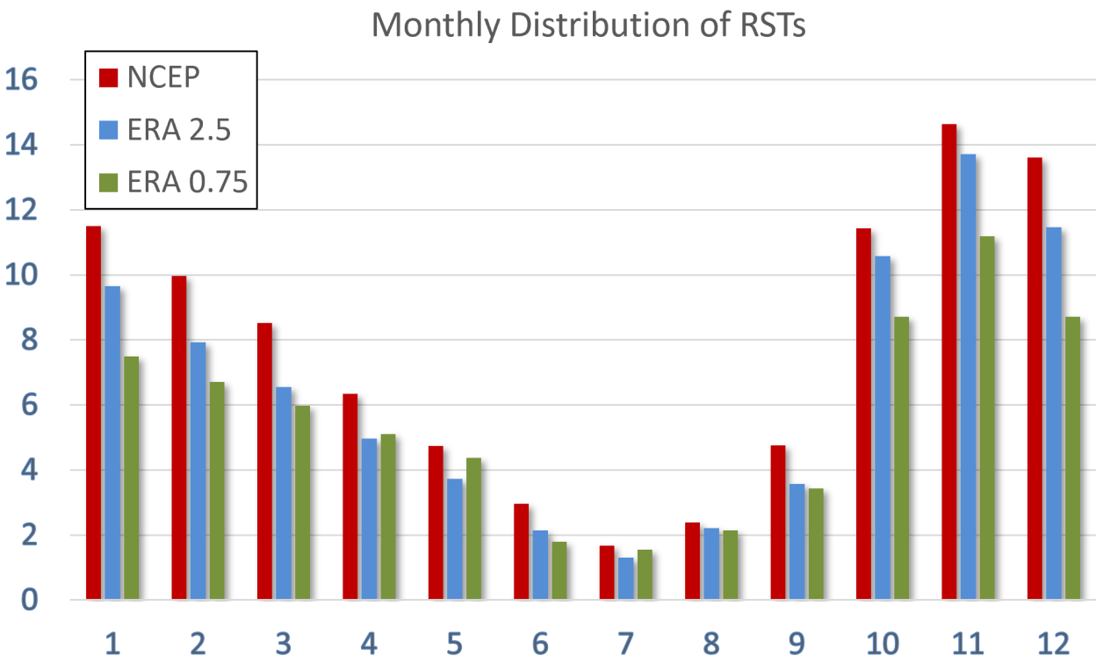

Fig. 7: Yearly distribution of RST days (%) according to the NCEP reanalysis data (red), and ERA Interim with 2.5°×2.5° and 0.75°×0.75° resolution (blue and green respectively).

The long-term mean yearly distribution derived from the three data bases (Fig. 7) shows more or less similar course with the following common characteristics: the autumn is the main season of RST, with a maximum is in November and a gradual and consistent decrease from December toward the yearly minimum in July. This course is consistent with that shown by Alpert et al. (2004b). The similarity in the annual course among the various data bases indicates that the climatological regional signature is clear.

**צביקה, מהו אחוז ימי אפיק ים סוף לפי כל בסיס נתונים?**

* + 1. Diurnal variation

The RST owes its existence, among others, to the lee effect implied by the mountain chains extending in the southeast-northwest orientation of the Red Sea (e.g., Dayan et al. 2001). This implies that the axis would be located along the Red Sea. As for the part of the axis that extends north of the Red Sea, over the Levant, its location may respond to the diurnal temperature variations in the temperature contrast between the Mediterranean and the adjacent land. In other words, it is expected to move eastward, inland, during the day hours and westward, toward the sea, during the night hours.

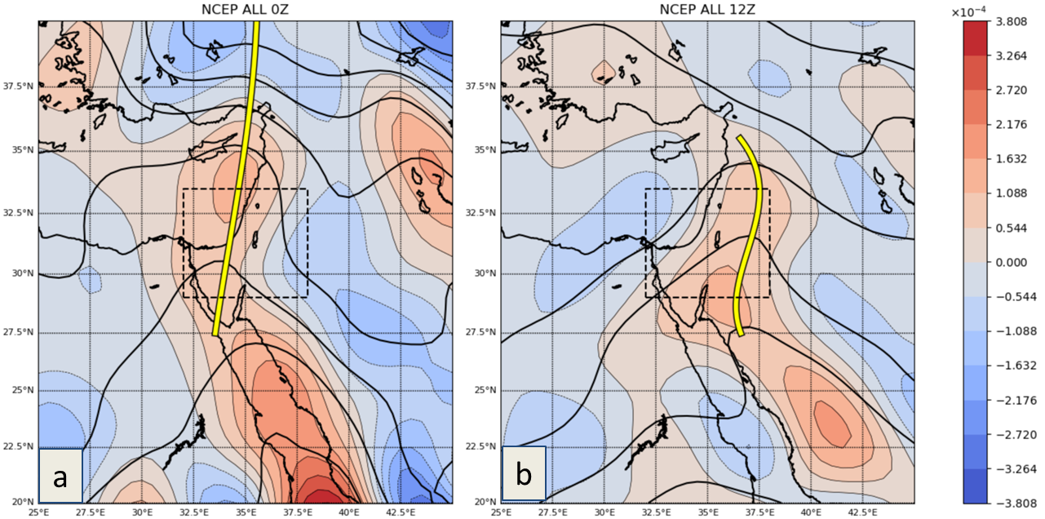

Fig. 5: Composite map of SLP (contours, in hPa) and geostrophic vorticity (colors, in s-1) for all days in which RST was identified based on the NCEP reanalysis for (a) 00UTC and (b) 12UTC. For each map the RST axis is derived as is done for individual maps (see Sec. 2.4).

Figure 7 shows two composite maps based on all of the days in which RST was identified in the NCEP reanalysis data. Figure 7a shows the results for 00UTC, which represent the night hours for the Levant (02LST), and Fig, 7b shows the results for 12UTC, representing the noon hours (14 LST), In each composite map the RST axis is derived in the same way as done for individual maps. It is clearly seen that in the day hours the axis shifts eastward 3° longitudes with respect to its position in the night hours, presumably because it is being attracted to the warmer land.

**צביקה, צריך טבלה עם מספר האפיקים בעלי ציר מזרחי, מרכזי ומערבי ל 00 ו 12 עבור כל בסיס נתונים (אולי בסוף נכלול רק את ה NCEP)**

* + 1. Long-Term trends

**צביקה, הפיק גרפי מגמה של שכיחות אפיקי ים סוף עבור השנה כולה ועבור עונת השיא (אוק-דצמבר) לפי כל בסיס נתונים עבור 1979-2016**

1. **Summary and discussion**

This study is the first attempt to identify the Red Sea Trough specifically, unlike previous synoptic classifications of the Levant (e.g, that of Alpert et al. 2004a), which cover all systems affecting the region. Each RST is classified as one of three types, according to the location of the trough axis with respect to 35°E longitude. For that end, we use the sea level pressure relative geostrophic vorticity.

These two fields are interpolated into a common basis of 0.5°x0.5° resolution and undergo a series of examinations in order to identify whether the map reflects RST. The first three check whether the situation meets the RST definition. i.e. the pressure drops from north to south, average positive relative vorticity exists over the area of interest and whether a distinct continuous trough axis extends from the low pressure in the south toward the Levant. An additional condition was imposed to prevent false identifications in cases in which there is a pronounced closed cyclone in the vicinity, south of the domain.

The algorithm was applied on the ERA Interim, in 2.5°×2.5° and 0.75°×0.75° resolution and the NCEP reanalysis, with 2.5°×2.5° resolution in order to examine its flexibility for being applied on a wide spectrum of data sources and resolution.

The evaluation of the algorithm was first done by comparing its identification of RST to that of three trained forecasters. The fit varied between 87% and 96% for a series of experiments. An additional comparison was don on the classification (into the 3 types) yielding 79% agreement. It seems that the algorithm proposed here overcome a major part of the weaknesses in the current automatic synoptic classifications developed for the Levant region. The main improvement is the focus, which is given to the RST alone and to the region which it covers. Another advantage is that the algorithm search for the trough axis in order to classify the RST according to its location.

The algorithm was applied on the 3 data sets separately in order to compare the effect of the analysis methods and the spatial resolution on the RST distribution. The annual frequency of the RST varied among the three data bases between ??% and ??%. The highest match was found between the two data sets of the ERA Interim, 85%, presumably due to the similar processing method applied by the two of them. The lowest match was found between the NCEP (2.5°×2.5° resolution) and the fine resolution (0.75°×0.75°) data set of ERA Interim, 78%, due to the cumulative effect of the different resolutions and different methods of analysis. Another aspect of this comparison is biases existing between data sources. The most pronounced is the tendency of the NCEP data set (with 2.5°×2.5° resolution) to produce maps that are identified as 'RST east', whereas according to Era Interim data set, with 0.75°×0.75° resolution, the maps for the same dates (in 8.8% of the days) they were identified as 'No RST' maps. Similar tendency, though slightly weaker, was found between the two data bases with the same resolution (2.5°×2.5° resolution). These bias is, at least partly, reflects cases in which an RST was noted both data bases, but while in the Era Interim maps it was located east of the area of interest, in the NCEP maps it was shifted to the west, and found within the eastern part of the area of interest. This difference can be attributed to difference in the topographical setting between the two data centers, which can lead to differences in the calculation of the SLP.

The long-term mean yearly distributions derived from the 3 data bases show the same characteristics, i.e., the autumn is the main season of RST, with a maximum is in November, and a gradual and consistent decrease from December toward the yearly minimum in July.

The similarity in the climatic features among the data bases implies that the algorithm is stable with respect to climatic ctusies. Hence, if the application of our algorithm on climate models will indicate climatological changes for the future, the may reflect differences in the physics included in the models or real expected change.

The RST annual average frequency is ** (average of the data bases), which assess that the this system is the second most frequent in the region, after the Persian Trough (see also Alpert et al. 2004a, 2004b). The application of the algorithm on both day and night maps gave us the first opportunity to show that the trough axis has a diurnal oscillation; it tends to be near the eastern coast of the Mediterranean at nighttime (00UTC) and shifts eastward (inland) at noontime (12UTC). This may be attributed to the warming of the continent during the day hours, This indicates that at least in its northern end this synoptic scale system has meso-scale features.

Long-term trend

The fully automated algorithm is not tailored to any predetermined spatial resolution, so it is applicable to a variety of reanalysis datasets, operational forecast model results and climate model outputs.

An important missing link in the RST classification is the absence of any automatic method which is capable to distinguish between 'active RST', which is accompanied by tropical-like weather conditions, and 'non-active RST'. The development of such algorithm is the next step of the present study.

**References**

Alpert P, Osetinsky I, Ziv B, Shafir H (2004a) Semi-objective classification for daily synoptic systems: Application to the eastern Mediterranean climate change. Int J Climatol, 24:1001-1011

Alpert P, Osetinsky I, Ziv B, Shafir H (2004b) A new seasons definition based on the classified daily synoptic systems, an example for the Eastern Mediterranean, Int J Climatol, 24:1013-1021

Ashbel D (1938) Great floods in Sinai Peninsula, Palestine, Syria and the Syrian Desert, and the influence of the Red Sea on their formation. Q J Roy Met Soc, 64:635-639

Ben-Rubi P. 1980. An Objective Definition of Red Sea Trough in Israel. MSc Thesis, The Hebrew University of Jerusalem, (in Hebrew)

Dayan U, Ziv B, Shoob T, Enzel Y (2008) Suspended dust over southeastern Mediterranean and its relation to atmospheric circulations. Int J Climatol, 28:915-924

Dayan U, Tubi A, Levi I (2012) On the importance of synoptic classification methods with respect to environmental phenomena. Int J Climatol, 32(5):681-694

Dee DP, Uppala SM, Simmons AJ, Berrisford P, Poli P, Kobayashi S, Andrae U, Balmaseda MA, Balsamo G, Bauer P, Bechtold P, Beljaars ACM, Van de Berg L, Bidlot J, Bormann N, Delsol C, Dragani R, Fuentes M, Geer AJ, Haimberger L, Healy SB, Hersbach H, Hףlm EV, Isaksen L, Kוllberg P, Kohler M, Matricardi M, McNally AP, Monge-Sanz BM, Morcrette J-J, Park B-K, Peubey C, De Rosnay P, Tavolato C, Thיpaut J-N, Vitart F. 2011. The ERA-Interim reanalysis: configuration and performance of the data assimilation system. *Q. J. R. Meteorol. Soc.* **137**(656): 553–597, doi: 10.1002/qj.828.

Enzel Y, Amit R, Dayan U, Crouvi O, Kahana R, Ziv B, Sharon D (2008) The climatic and physiographic controls of the eastern Mediterranean over the late Pleistocene climates in the southern Levant and its neighboring deserts. Glob Planetary Change, 60:165-192

Erel Y Tirosh O, [Kessler](http://link.springer.com/search?facet-creator=%22N.+Kessler%22) N, Dayan U, Belkin S, Stein M, Sandler A, Schauer JJ (2013) Atmospheric Particulate Matter (PM) in the Middle East: Toxicity, Trans-boundary Transport, and Influence of Synoptic Conditions. In: Censi P, Darrah T, Erel Y (Eds.) [Medical Geochemistry](http://link.springer.com/book/10.1007/978-94-007-4372-4) - Geological Materials and Health. Springer ScienceCBusiness Media Dordrecht, 31-46

European Centre for Medium-Range Weather Forecasts. 2009. ERA-Interim Project. Research Data Archive at the National Center for Atmospheric Research, Computational and Information Systems Laboratory, Boulder, CO. <http://rda.ucar.edu/datasets/ds627.0>. (accessed 29 December 2014).

Frakes B, Yarnal B (1997) A procedure for blending manual and correlation-based synoptic classifications. Int J Climatol, 17:1381-1396

Ganor E, Osetinsky I, Stupp A, Alpert P (2010) Increasing trend of African dust, over 49 years, in the eastern Mediterranean. J Geophys Res, 115:D07201

Goldreich Y. 2003. The Climate of Israel: Observation, Research and Application. Springer: Israel, Kluwer Academic/Plenum Publishers: Netherland, 298.

Haseler J, Hernandez A, Kelly GA, LI X, Onogi K, Saarinen S, Sokka N, Allan RP, Andersson E, Arpe K, Balmaseda MA, Beljaars ACM, van de Berg L, Bidlot J, Bormann N, Caires S, Chevallier F, Dethof A, Dragosavac M, Fisher M, Fuentes M, Hagemann S, Hlm EV, Hoskins BJ, Isaksen L, Janssen PAEM, Jenne R, McNally AP, Mahfouf J-F, Morcrette J-J, Rayner NA, Saunders

Kalnay E, Kanamitsu M, Kistler R, Collins W, Deaven D, Gandin L, Iredell M, Saha S, White G, Woollen J, Zhu Y, Chelliah M, Ebisuzaki W, Higgins W, Janowiak J, Mo KC, Ropelewski C, Wang J, Leetmaa A, Reynolds R, Jenne R, Joseph D (1996) The NCEP/NCAR 40-Year reanalysis project. Bull Amer Meteor Soc, 77:437-471

Kistler R, Kalnay E, Collins W, Saha S, White G, Woollen J, Chelliah M, Ebisuzaki W, Kanamitsu M, Kousky V, Van Den Dool H, Jenne R, Fiorino M (2001) The NCEP-NCAR 50-year reanalysis: monthly means CD-ROM and documentation. Bull Amer Meteor Soc, 82:247-267

Koplowitz R (1973) An Objective Classification of Synoptic Pressure Field Patterns of the Eastern Mediterranean Basin for use in Synoptic-Climatological Studies. MSc Thesis, The Hebrew University, Jerusalem.

Lionello P. (Ed.) (2012) The Climate of the Mediterranean Region, From the past to the Future, Elsevier, Amsterdam, Netherlands, 502pp

Ronberg B (1984) An Objective Weather Typing System for Israel, a Synoptic Climatological Study. PhD Thesis, Hebrew University, Jerusalem

RW, Simon P, Sterl A, Trenberth KE, Untch A, Vasiljevic D, Viterbo P, Woollen J. 2005. The ERA-40 re-analysis. Q. J. R. Meteorol. Soc. 131(612): 2961–3012, doi: 10.1256/qj.04.176.

Saaroni H, Ziv B, Bitan A, Alpert P (1998) Easterly wind storms over Israel. Theor Appl Climatol, 59:61-77

Shafir H, Ziv B, Neeman BU, Alpert P (1994) Objective classification of synoptic situation and its implication for economic evaluation of wind energy availability. Meteorologia be-Israel, 3:29-49 (in Hebrew)

Tsvieli Y, Zangvil A (2005) Synoptic climatological analysis of “wet” and “dry” Red Sea Troughs over Israel. Int J Climatol, 25:1997-2015

Uppala SM, Kוllberg P, Simmons AJ, Andrae U, Bechtold P, Fiorino M, Gibson JK,

Uppala SM, Kוllberg P, Simmons AJ, Andrae U, Bechtold P, Fiorino M, Gibson JK, Haseler J, Hernandez A, Kelly GA, Li X, Onogi K, Saarinen S, Sokka N, Allan RP, Andersson E, Arpe K, Balmaseda MA, Beljaars ACM, van de Berg L, Bidlot J, Bormann N, Caires S, Chevallier F, Dethof A, Dragosavac M, Fisher M, Fuentes M, Hagemann S, Hףlm EV, Hoskins BJ, Isaksen L, Janssen PAEM, Jenne R, McNally AP, Mahfouf J-F, Morcrette J-J, Rayner NA, Saunders RW, Simon P, Sterl A, Trenberth KE, Untch A, Vasiljevic D, Viterbo P, Woollen J. 2005. The ERA-40 re-analysis. Q. J. R. Meteorol. Soc. 131(612): 2961–3012, doi: 10.1256/qj.04.176.

Ziv B., U. Dayan and D. Sharon, 2005: A mid-winter, tropical extreme flood-producing storm in southern Israel: Synoptic scale analysis, Meteor. Atmos. Phys., 69: 91-102.